Nepal College of Information Technology
Re-Assessment
Fall 2011
Program : BE ELX Time : 3 hrs
Semester : Fall FM : 100
Subject : Control System PM : 50

- Candidates are requested to give their answer as far as practicable in their own words.
- The figure in the margin indicates the full marks
- Attempt ALL question
1. a) Write down the defining equation for the liquid level system shown in the below figure. Obtain their transfer function also. 7
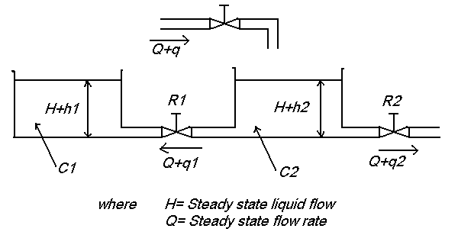

b) Draw the overall block diagram for armature controlled DC motor. Also find the overall transfer function.

2. For the translational mechanical system is shown in figure below 15
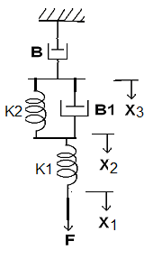
Find
a) the force balance equation that describe the motion of the system
b) Obtain the force-voltage analogy and
c) Obtain the force-current analogy.

3. Find the overall transfer function C(s)/R(s) for the following system using both block diagram reduction technique and SFG. 15
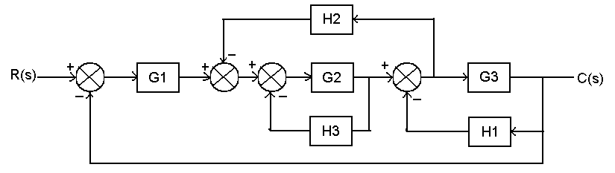

4. Sketch the root locus for the open loop transfer function of a unity feedback control system given below whose open loop transfer function is given by
G(s)H(s)= k / {s(s+3) (s²+2s+2)} 15
5. a) The open loop transfer function of a unity feedback control system is given by
G(s)= K/{s(1+sT)}
By what factor should the gain K, should be multiplied so that the damping ratio of the unit step response of the system is increase from 0.2 to 0.8. 8
b) The characteristics equation of a feedback system
S⁴+20KS³+5S²+10S+15=0
Find the range of K for which system is stable 7

6. a) The open loop transfer function of a certain unity feedback system is
G(s)= 50/{s(1+0.25s)(s+0.1s)}
Construct the Bode Plot. Also determine gain margin and phase margin and check stability. 8
b) Find the state space model of the transfer function
G(s)=5/{(s+1)(s+2)}
Using Direct decomposition method 7

7. Write short notes on (Any two): 5*2=10
a) Dominant poles of transfer function
b) Niquist plot versus Bode plot
c) Rise time (tr) for a second order system

